Michigan Department of Natural Resources
www.michigan.gov/dnr

2015 Round 2
Wildlife Habitat Grant Program Handbook

Wildlife Division / Grants Management Section

Michigan Department of Natural Resources Mission Statement
"The Michigan Department of Natural Resources is committed to the conservation, protection, management, use and enjoyment of the State’s natural and cultural resources for current and future generations."
Natural Resources Commission Statement
The Natural Resources Commission, as the governing body for the Michigan Department of Natural Resources, provides a strategic framework for the DNR to effectively manage your resources. The NRC holds monthly, public meetings throughout Michigan, working closely with its constituencies in establishing and improving natural resources management policy.
The Michigan Department of Natural Resources (DNR) provides equal opportunities for employment and access to Michigan's natural resources. Both State and Federal laws prohibit discrimination on the basis of race, color, national origin, religion, disability, age, sex, height, weight or marital status under the U.S. Civil Rights Acts of 1964 as amended, 1976 MI PA 453, 1976 MI PA 220, Title V of the Rehabilitation Act of 1973 as amended, and the 1990 Americans with Disabilities Act, as amended.
If you believe that you have been discriminated against in any program, activity, or facility, or if you desire additional information, please write: Human Resources, Michigan Department of Natural Resources, PO Box 30028, Lansing MI 48909-7528, or Michigan Department of Civil Rights, Cadillac Place, 3054 West Grand Blvd, Suite 3-600, Detroit, MI 48202, or Division of Federal Assistance, U.S. Fish and Wildlife Service, 4401 North Fairfax Drive, Mail Stop MBSP-4020, Arlington, VA 22203
For information or assistance on this publication, contact Grants Management, Michigan Department of Natural Resources, PO Box 30425, Lansing MI 48909-7925.

To find out more information on the Natural Resources Commission see http://www.michigan.gov/dnr/0,4570,7-153-65134_65145---,00.html

TABLE OF CONTENTS

Schedule for Wildlife Habitat Grant Program 1
Introduction 2
Grant Program Eligibility and Requirements 2
Eligible Grant Applicants 2
Grant Limits and Commitment Requirements 2
Program Goals 2
Region and Program Priorities 3
Eligible Costs 5
Ineligible Projects 6
Ineligible Costs 6
Application Process 7
Instructions for Completing Application (PR1946) 7
DNR Application Review Process 11
Grant Scoring Criteria 11
Ineligible Applications 12
Special Notes 13
Project Preparation for funded Applications 13
Project Agreements 13
Project Changes 14
Contracting and Procurement Requirements 14
Permits, Building Codes and Americans with Disabilities Act 15
Project Reporting Requirements 15
Wildlife Habitat Grant Program Recognition 15
Payment of Grant Funds 16
Documentation Requirements for Project Work Being Done on Lands not Owned by Grantee 16
Advance Payment 16
Expenditure Documentation Requirements 16
Reporting Force Account Labor and Equipment 17
Documenting Donations 19
Reporting Mileage Expense Reimbursement for Compensated Workers 20
Reporting Reasonable Overhead/Indirect Cost 20
Project Completion and Final Date 20
Appendix A: More Bang for Your Buck Brochure 22
Appendix B: Wildlife Division Regions 24
Appendix C: Notification of Contractor/Vendor Selection and Bid Tabulation Approval 25
Appendix D: Example of Private Landowner Authorization Letter 26
Appendix E: Example of Public Landowner Authorization Letter 27
Appendix F: Volunteer Labor Sign-In and Time Record 28

Schedule for Wildlife Habitat Grant Program

Request for Proposals Begins June 1, 2015
Grant Application Due (must be postmarked by this day) July 10, 2015
DNR Review & Selection Process Completed September 18, 2015
Awards Announced by Director October 1, 2015
Project Periods Begins Upon Execution of grant agreement or October 1, 2015
(Whichever is later)
Project Schedule Follow work plan in Appendix A of Project Agreement Plan
Period Ends September 30, 2016
Final Project Report Due November 14, 2016

Introduction
The Wildlife Habitat Grant Program (WHGP) is administered by the Michigan Department of Natural Resources (DNR) through a cooperative effort between Wildlife Division and Grant Management. The (WHGP) began in October 2013 and will be funded with a portion of hunting and fishing licenses that are sold each year. The WHGP’s purpose is to provide funding to local, state, federal and tribal units of government, profit or non-profit groups, and individuals to assist the Wildlife Division with developing or improving wildlife habitat for game species. More information and grant forms can be found on the Grants tab of the Michigan DNR website or at: http://www.michigan.gov/dnr/0,4570,7-153-58225_67395-324696--,00.html.

Grant Program Eligibility and Requirements

Eligible Grant Applicants
Any local, state, federal or tribal units of government, profit or non-profit groups, or individuals in Michigan who will commit to maintain the area to be improved for the useful life of the project may apply for a Wildlife Habitat Grant. Useful life is defined on a case by case basis as the period of time during which an improvement is capable of fulfilling its intended purpose with adequate, routine maintenance. Possible useful life examples for projects would be: 1-3 years for wildlife food plots and 10 years for perennial herbaceous plantings.

Please note: if you are an individual and your application is funded, you will receive a 1099 form from the State of Michigan for the grant funds you receive in each calendar year

Grant Limits and Commitment Requirements
The minimum grant amount is $15,000, and the maximum grant amount you can apply for is the amount of funds appropriated in a given fiscal year.

The applicant must commit to provide at least 10% of the total project cost. The 10% may be in any of the following forms:
- Applicant’s own cash
- Applicant’s own force account labor, equipment, or materials
- Donations of cash, materials, equipment or services by others – requires letter(s) of commitment from donors at time of application
Scores for projects where applicant commits to provide in excess of 10% will be increased based upon the amount committed.
(NOTE: time, supplies & materials, equipment provided by DNR and other state grants are not eligible to be used as part of the 10% applicant commitment amount)

Program Goals
The primary goal of this program is to enhance and improve the quality and quantity of game species habitat in support of specific goals from the Wildlife Division’s strategic plan, The GPS.

Specifically:
- GPS Goal 2 – Manage habitat for sustainable wildlife populations in a changing environment
The key priorities to be addressed by this program include:
More Bang for Your Buck (See Appendix “A” for more information)
- Expanding big game hunting adventures
- Bringing back quality pheasant hunting to Michigan
- Making Michigan regionally known for our great diversity of high-quality waterfowl hunting
- Creating outstanding grouse, woodcock, and turkey hunting in Michigan
- Expanding the challenge of small game hunting for squirrel, rabbit and hare
- Expanding recreational shooting opportunities on public and private lands
- Preserving and promoting Michigan’s hunting and trapping heritage

Region and Program Priorities
(See Appendix B to determine which region your project is located in)
- Southeast Region
- Develop or maintain wildlife openings and/or development of food plots on State Wildlife Areas and State Forest lands.
- Develop food plots that target featured game species for the region.
- Develop and maintain wildlife openings for wildlife, especially within the forested cover types.
- Grasslands/savannas
- Develop and maintain, or contribute to large (250 acre) grassland complexes. Emphasis will be on the game areas identified in “More Bang for Your Buck”.
- Develop brush piles for rabbit habitat, especially near meadows and grasslands.
- Early successional forest (aspen)
- Create edge habitat that provides wildlife cover especially in areas that currently have limited cover.
- On non-commercial timber stands, utilize cutting to obtain early successional forests (especially aspen types) and encourage retaining fruit bearing shrubs and hard mast trees.
- Wetlands
- Develop and update water control structures and dikes at managed waterfowl and wetland areas.
- Southwest Region
- Develop or maintain wildlife openings and/or development of food plots on State Wildlife Areas and State Forest lands.
- Develop or maintain wildlife openings and/or development of food plots on State Game Areas (SGAs).
- Grasslands/savannas
- Projects that contribute to large (250 acre) grassland complexes are most desired and may have to include working with private landowners nearby SGAs.

- Brush piles for rabbit habitat within grassland complexes. Priority SGAs include Allegan (Farm Unit), Augusta Creek, Gratiot-Saginaw , Maple River, Rose Lake and Three Rivers.
- Smaller complexes can be considered on SGAs in the southern half of the region as well.
- Early successional forest (aspen)
- Mechanical treatment of forest stands to obtain early successional forests (especially aspen types) and retain fruit bearing shrubs and hard mast trees.
- Techniques that provide wildlife cover especially in areas that currently have limited cover.
- SGAs in the northern half of the region all have areas where this type of management is desired.
- Allegan and Barry SGAs in the south may have some opportunities for early successional management.
- Wetlands
- Develop, maintain and update water control structures and dikes at managed waterfowl and wetland areas, establish flooded agricultural crops, restoration of moist soils complexes, restoration of natural water levels in drained or tiled areas.
- Although wetland management projects will be considered for all SGAs in the region priority will be given to projects at Allegan, Dansville, Gratiot-Saginaw Langston, Maple River, Martiny Lake, and Muskegon SGAs.
- Northern Lower Peninsula Region
- Develop or maintain wildlife openings and/or development of food plots on State Wildlife Areas and State Forest lands.
- Emphasis will be placed on more long term sustainable herbaceous cover and forage plantings which restore openings that are degraded due to brush and undesirable herbaceous encroachment.
- Applicants should contact local biologists and Field Operations Managers to coordinate effort.
- Grasslands/savannas
- Projects that contribute to large (250 acre) grassland complexes, primarily in elk range, but also located in the Baldwin and Traverse City units, are most desired and may have to include working with adjacent private landowners.
- Brush piles for rabbit habitat within grassland complexes.
- Priority locations to be determined by local biologists.
- Early successional forest (aspen)
- Mechanical treatment of forest stands to obtain early successional forests (especially aspen types) and retain fruit bearing shrubs and hard mast trees.
- This will typically require non-commercial treatments which do not sell under the normal timber sale process.
- Wetlands
- Develop, maintain and update water control structures and dikes at managed wetland areas, restoration of moist soils complexes, restoration of natural water levels in drained or tiled areas.
- Although wetland management projects will be considered for all areas in the region priority will be given to projects identified on the Regional priority list.
- Applicants should consult with the local DNR wildlife biologist to discuss these opportunities.
- Deer wintering complexes
- Protect/enhance conifer cover and food supplies as identified by local biologists.
- Mast producing trees
- Maintain and expand mast-producing species such as oak and beech, focusing on areas where disease is a threat.
- Establishment of soft mast (cranberries, crab apples, etc.) to promote winter food sources for wild turkey in high snow fall zone.
- Pruning of existing fruit trees on state owned lands which will improve fruit production.
- Woodcock management
- Maintain the lowland brush component through regeneration activities by mowing brush in areas within the identified woodcock management zone.
- Upper Peninsula Region
- Deer wintering complexes
- Protect/enhance conifer cover and food supplies.
- Early successional forest (aspen)
- Maintain the aspen resource in a variety of age classes.
- Mast producing trees
- Maintain and expand mast-producing species such as oak and beech, focusing on areas where disease is a threat.
- Forest openings
- Maintain forest openings of various sizes, ranging from small clearings to large complexes or savanna in appropriate locations.
NOTE: This list is not all inclusive and requires that applicants consult with DNR staff.

Eligible Costs
Only those costs directly associated with completing the project and incurred during the project period are eligible for reimbursement, with the exception of engineering, design and design administration costs. Categories of eligible costs include:
- Salaries/wages (including fringe benefits) for on the ground paid labor costs and/or project administration.
- Donated services/volunteer labor (credited at minimum wage).
- Mileage for compensated workers when using personal vehicle for project travel valued at the current IRS standard business rate (currently $.575/mile).
- Meals for compensated workers when working outside their normal work area (maximum $8.50 for breakfast and/or lunch and $19.00 for dinner when documented with a receipt).
- Onsite group meals for volunteer laborers.
- Materials specific to the funded project (purchased or donated).
- Contractual services (must be competitively bid if $10,000 or more).
- Indirect contractual services costs (no more than 10% of total contract cost).
- Reasonable overhead/indirect costs (e.g.: office supplies and materials, rent, utilities) (no more than 10% of total project costs) (note: salaries/wages are not eligible as overhead/indirect costs).
- Engineering, design, and/ or project administration (no more than 30% of total project cost).
- Purchase of small hand tools and safety equipment not to exceed $500 per item (e.g.: shovels, rakes, manual spreaders, backpack sprayer, drip torch, gloves, goggles, chaps etc.).
  - Please note: if qualifying small hand tools and safety equipment are purchased using this grant funding, there is an expectation that these items will be used in any future grants of similar nature and purchase of similar items in future grants must be justified and approved by DNR prior to being eligible.
- Equipment (donated or rented) (eg: chain saws, wood chippers, atvs, vehicles, etc.).
- Fuel costs for equipment used during project construction (if MDOT Schedule “C” Rates are not used or cost is not included in equipment rental agreement).
- Project signs.
- Permit application fees for permits required for the project.
  - Contact regulatory agencies well in advance of applying for a grant to determine “permitability” of the proposed project and to avoid delays if the project is funded
- Engineering, design and design administration costs incurred up to 1 year prior to the project period specified in the project agreement or amendment.
NOTE: These costs are at your own risk and will not be reimbursed if a grant is not awarded.

Ineligible Projects
Projects with scope of work outside the grant focus area are not eligible for Wildlife Habitat Grant support. Within the focus area, the following types of projects are also not eligible:
- Land acquisition or acquisition of rights in land.
- Studies and/or management plans.
- Projects located outside the state of Michigan.
- Projects where the primary habitat improvement or development is for agricultural purposes
- Projects where the primary activity is invasive species removal or prevention.
- Projects where the primary improvement or development is the construction of buildings, viewing structures, seating structures, or any other type of structure that does not create or enhance wildlife habitat.

Ineligible Costs
For all projects, the following items are examples of costs that are ineligible for reimbursement:
- Costs incurred outside of the project period specified in the project agreement or amendment.
- Salaries/wages not directly related to the project.
- Time, supplies & materials, or equipment provided by the DNR.
- Lodging for compensated workers.
- Lodging or mileage for volunteer laborers.
- Conference fees and speaker fees.
- Purchase of equipment (e.g.: chain saws, wood chippers, atvs, vehicles, etc.).

Application Process
While preparing your WHGP application, we recommend that you work with the local region wildlife personnel where your project is located to ensure the project is in line with region priorities. (See “Appendix B” for contact information)

Application Due Date
Provide two (2) hard copy versions and one (1) electronic version of each grant application packet to the DNR, Grants Management Section, Wildlife Habitat Grant Program. Electronic version may be in the form of a USB drive or CD. Applications must be postmarked no later than July 10, 2015. Late applications will not be considered for funding.

Application Forms
Grant applications must be submitted on a current DNR form for the WHGP. Forms may be downloaded from the Michigan DNR website at www.michigan.gov/dnr-grants. If submitting more than one project for funding consideration, complete a separate application form and include all required information for each project. Also, tell us what project is your “priority project”.

Required Content for all Application Packets:
Wildlife Habitat Grant Program Application (PR1946) – two copies fully completed and signed
Application narrative – two copies
Project location map – two copies
Project spatial data – GIS polygons or shapefiles. If possible (electronic only); project map with project work areas drawn in if GIS files are not possible – one copy
Documentation of local match sources (commitment letters) – two copies (i.e., monetary commitment letters, donation commitment letters, grant award letters, etc.)
Photographs of the site – two paper copies or one digital copy (digital images submitted on CD or USB drive is preferred over paper photos)
Electronic Version of Grant Application Packet – one copy (submitted on CD or USB drive)
Correspondence regarding regulatory permitting issues – two copies (if applicable)
Deed or most recent property tax statement showing landowner name and legal description if work to be done is located on applicant’s own property – two copies

NOTE: If work to be done is located on property not owned by applicant, please see “Payment of Grant Funds” section of this handbook for proof of landowner authorization requirements.

Instructions for Completing Application (PR1946)
Assembling the information needed to submit a complete application package takes time - it is important to start the process as early as possible.

Part 1: General Information
- Applicant Information:
  - The Authorized Representative is a person who represents the applicant, is able to answer questions regarding the application, and will oversee project administration if a grant is awarded.
  - The Federal Employer Identification Number is required and allows the DNR to make grant payments to the Grantee. Please provide the employer ID number for the applicant organization. Individuals applying for a grant must provide their social security number.
  - Provide documentation of site control with a deed or most recent property tax statement if work to be done is located on applicants own property.
Please note: If your project is funded, you must be registered in the State's vendor system to receive funds. All grant funds will be paid by Electronic Funds Transfer (EFT). Once registered, it is up to you to maintain the information on the site, including the accurate Federal ID number, vendor name, bank account information, address, etc. To either register for the first time or update your account, please visit www.michigan.gov/budget and access the Contract and Payment Express site (on the lower left side of the screen).
- Property Owner(s) Information:
  - Provide name of current property owner(s) along with address, telephone and e-mail (if available) for property where project work is proposed.
- Project title:
  - Provide a short title for the project to be done (i.e. Habitat Restoration in Pinckney SGA).
- Brief Description of Proposal:
  - Provide a short overview of the project and what will be accomplished upon completion.
- Project Narrative:
  - Provide a detailed description of how the project meets the application scoring criteria and should also include how project items will be completed.
This narrative is critical to the evaluation and scoring of your application.
- Project Location:
  - Provide map(s) and other graphic information in clear, legible, detailed and appropriately labeled 8.5 inch by 11 inch size. You may also submit larger versions of any or all of them. DNR staff use these materials to help find and evaluate your site and application.
- Estimated Project Cost:
  - Total project cost is the total estimated amount it will take to complete the project. This amount should equal the total of grant amount requested plus local committed funds.
- Source of local committed funds:
  - General Funds is the amount of cash the applicant commits to provide out of their own pocket toward the project.
  - Cash Donations from others is the amount of cash that someone, other than the applicant, commits to provide out of their own pocket toward the project. A commitment letter must be provided for this amount with the application packet.
  - Value of Donated Material & Labor from others is the total estimated value of donated materials and/or labor that someone, other than the applicant, commits to provide out of their own pocket toward the project. A commitment letter must be provided for this amount with the application packet. (Note: labor must be valued at minimum wage).
  - Other is the expenses incurred by the applicant for force account labor, materials and/or equipment or other grants awarded for the same scope of work by another entity. A commitment/award letter must be provided with the application packet for other grants awarded.
Part II: Estimated Project Costs
- Scope Items:
  - List the total cost of each Project Scope Item; these are the proposed project components to be completed or purchased. Be sure that scope items are listed the same way (have the same name) and that budget figures are consistent throughout the grant application.
  - Planning and Engineering is not to exceed 30% of the total project costs as stated in the Subtotal column.
  - Total Estimated Project Cost should be the same amount as the Total Project Cost in Part 1, #7.
- Itemized Budget:
  - The Itemized Budget provides the detailed costs for the project. Itemize the costs of each scope item and separate the costs into major budget categories (personnel costs, material and equipment, contractual items, and “other”). Refer to the Example Budget shown below.
  - For equipment owned by applicant, an estimate of the cost for its operation can be obtained from the Michigan Department of Transportation (MDOT) Equipment Rental Rates, Schedule C, Report 375 booklet for the year in which the equipment was used. Booklets can be obtained from the MDOT Maintenance Division by calling 517-322-3303 (TTY/TDD: 711 Michigan Relay Center) or writing to them at 6333 Old Lansing Road, Lansing, MI 48917, http://www.michigan.gov/documents/mdot/Equipment_Rental_Rates_2014_441996_7.pdf
  - Volunteer labor should not be valued greater than minimum wage unless a professional is performing work in their field of expertise (for example, a heavy equipment operator operating heavy equipment). Donated materials should be valued at their current market value and supported by receipts or other verification. If a grant is awarded, the methods of valuing donations are subject to DNR review and approval prior to the donations being approved.

An example of a budget is shown below.
PLEASE ROUND ALL NUMBERS TO THE NEAREST $1.
Example Budget
BUDGET CATEGORY |  |  | Total Project Cost
A. PERSONNEL COSTS:
 | SALARIES/WAGES
 | (# of workers x rate per hour x total hours)
10 x 10 x 200 |  |  | $20,000
PERSONNEL COSTS SUBTOTAL |  |  | $20,000
B. MATERIAL & EQUIPMENT:
(List each piece of equipment, rate/hour, material and cost/quantity)
 | Equipment Rate/Hour
Backhoe (200 hrs)  Truck (100 hrs) |  | $100 | $20,000
 |  | $ 65 | $6,500
 | Qty Material Cost
500 Stone (cu yd) |  | $10/cu yd | $5,000
MATERIAL & EQUIPMENT SUBTOTAL |  |  | $31,500
C. CONTRACTUAL ITEMS: (List by Bid Item)
Plant vegetation |  |  | $2,222
CONTRACTUAL SUBTOTAL |  |  | $2,222
D. OTHER:
MDEQ permit application fees |  |  | $472
OTHER SUBTOTAL |  |  | $472
TOTAL ESTIMATED PROJECT COST |  |  | $ 54,194
Part III: Work Plan
  - Indicate the estimated amount of work that will be accomplished in each quarter of the grant period. This information will also serve as the basis for the grant payment schedule if the project is approved for funding. Projects are required to be completed within the scheduled time frame. Project extensions will not be approved.
Part IV: Need and Benefit
  - This section is important for the DNR’s evaluation and scoring of the project. Be sure to relate the proposed project to the overall objectives and priorities of the WHGP. Briefly explain any coordinated efforts within the project area and how the public will benefit by completion of the project.
Part V: Certification
  - A person authorized to represent the agency or organization applying for the grant must sign here. Be sure to clearly print or type the person’s full name and title.

DNR Application Review Process

Grant Scoring Criteria
The DNR reviews all grant applications and determines their eligibility. For eligible project proposals, DNR scores applications using the following scoring criteria which reflect the goals and objectives of the program.
SCORING SUMMARY | MAXIMUM  SCORE
- Project Goals | 180
- Project Benefits & Outcomes | 150
- Management & Process | 120
TOTAL MAXIMUM SCORE | 450
- Project Goals (180 Maximum Score)
- What proportion of the proposed project helps the Division meet GPS Goal 2 – Manage habitat for sustainable wildlife populations in a changing environment?  - 60 = Entire proposed project meets program goal  - 40 = Most of the proposed project meets program goal  - 20 = Some of the proposed project meets program goal  - 0 = None of the proposed project meets program goal | 60
- What proportion of the proposed project helps the Division meet its More Bang for Your Buck priorities? (see Appendix “A” for more information)  - 60 = Entire proposed project meets program objective  - 40 = Most of the proposed project meets program objective  - 20 = Some of the proposed project meets program objective  - 0 = None of the proposed project meets program objective | 60
- What proportion of the proposed project helps the Division meet its Region priorities as listed in the Region and Program Goals section of the handbook?  - 60 = Entire proposed project meets program priorities  - 40 = Most of the proposed project meets program priorities  - 20 = Some of the proposed project meets program priorities  - 0 = None of the proposed project meets program priorities | 60
Maximum Possible Score (A+B+C) | 180
- Project Benefits & Outcomes (150 Maximum Score)
- Does the project provide comprehensive wildlife benefits (i.e., numerous species, large geographic area, improves habitat connectivity, etc.)?  - 50 = Yes, the project provides comprehensive wildlife benefits  - 40 = Yes, the project provides several wildlife benefits  - 20 = Yes, the project provides limited wildlife benefits  - 0 = No, the project does not provide wildlife benefits | 50
- Does the project provide comprehensive public benefits (i.e., multiple public activities enhanced, benefits public in large surrounding area, benefits large public population, etc.)?  - 50 = Yes, the project provides comprehensive public benefits  - 40 = Yes, the project provides several public benefits  - 20 = Yes, the project provides limited public benefits  - 0 = No, the project does not provide public benefits | 50
- What is the duration of benefits provided to the public and/or wildlife?  - 50 = Project benefits expected greater than 10 years  - 30 = Project benefits expected 5–10 years  - 20 = Project benefits expected 2–5 years  - 10 = Project benefits expected for 1 year  - 0 = Project benefits expected for less than 1 year | 50
Maximum Possible Score (A+B+C) | 150
- Project Management and Process (120 Maximum Score)
- What are the available secured committed funds?  - 30 = Applicant has > 50% eligible committed funds  - 25 = Applicant has 41–50% eligible committed funds  - 20 = Applicant has 31–40% eligible committed funds  - 15 = Applicant has 21–30% eligible committed funds  - 10 = Applicant has 11–20% eligible committed funds  - 0 = Applicant has 10% eligible committed funds | 30
- Is the requested project funding adequate to complete the proposed work?  - 30 = Requested project funding is adequate to complete proposed work  - 0 = Requested project funding is not adequate to complete proposed work | 30
- Do the application and narrative provide sufficient explanation of the project work plan?  - 30 = The application and narrative provide all necessary details of the work plan  - 15 = The application and narrative provide some necessary details of the work plan  - 0 = The application and narrative provide no details of the work plan | 30
- Does the applicant and project time have the experience and capacity to lead and complete the project?  - 30 = Applicant and team is fully capable of completing project  - 15 = Applicant and team is partially capable of completing project  - 0 = Applicant and team is unlikely capable of completing project | 30
Maximum Possible Score (A+B+C+D) | 120

Ineligible Applications
Ineligible applications are those which: are submitted after the due date, do not meet the minimum grant amount or provide insufficient committed funds. Applications not submitted on the proper form, or that are incomplete may also be considered ineligible for funding assistance.

Applications are ranked based on the final scores. Projects are recommended for funding, based on a combination of scoring criteria, project type, ownership type, and geographic location, dependent upon funds available for the program. A list of the projects recommended for funding is approved by Wildlife Division and presented to the DNR Director for approval. Following approval, all applicants are sent notification of the outcome.

Special Notes
Grant projects must comply with all applicable natural resource and environmental protection laws and state and local building codes.

Grantees are responsible for obtaining all necessary local, state and federal permits for the completion of projects approved for funding through the WHGP. Contact regulatory agencies well in advance of applying for a grant to determine “permit-ability” of the proposed project and to avoid delays if the project is funded. Apply for permits prior to any anticipated construction activities. This can be done upon DNR grant award notification for the project or as otherwise directed by the DNR. Award of a grant by the DNR in no way ensures or implies that all applicable permits will be issued.

Local agencies may include:
  - County Health Department
  - County Road Commission
  - County Drain Commissioner
  - Local Zoning Administrator
  - Building Inspector
State agencies may include:
  - State Historic Preservation Office (MSHDA) (www.michigan.gov/mshda)
  - Michigan Department of Environmental Quality (www.michigan.gov/deq)
  - Michigan Department of Natural Resources (www.michigan.gov/dnr)
  - Michigan Department of Community Health (www.michigan.gov/mdch)
  - Michigan Department of Transportation (www.michigan.gov/mdot)
  - Michigan Department of Agriculture and Rural Development (www.michigan.gov/mda)
Tribal governments may include any federally recognized tribe.
Federal agencies may include:
  - U.S. Department of the Army, Corp of Engineers (www.lre.usace.army.mil)
  - U.S. Environmental Protection Agency (www.epa.gov)
  - U.S. Department of Interior, Fish and Wildlife Service (www.fws.gov)
  - U.S. Department of Agriculture, Forest Service (www.fs.fed.us)
  - U.S. Geological Survey (www.usgs.gov)

Project Preparation for funded Applications
Once the DNR has completed the selection process, all applicants will be notified in writing of the outcome. Grantees whose projects are selected for funding will need to be in regular contact with the Michigan DNR Wildlife Division, WHGP Coordinator to ensure each step explained below is carried out in a coordinated manner.

Project Agreements
After the selection process, the grantee and DNR will enter into a project agreement to deliver the grant funding. The project agreement is prepared by the DNR and includes the following key specifications:
  - Grantee authorized representative for the project.
  - DNR Wildlife Division - WHGP Coordinator for the project.
  - Project period; beginning and ending dates for completion of the project.
  - Requirement that the project be completed as specified in the grant application.
  - Indication of the grant amount and local committed funds contributing to the project.
  - Obligations of the grantee to complete and maintain the project
Project agreements must be signed by the grantee and returned to the DNR within thirty (30) days of the date of issue or the grant may be cancelled by the DNR. During this 30-day time period, the grantee is required to review the work plan and project budget to be sure they are current and correct. Changes to the work plan and/or budget need to be approved in writing as explained below.

Project Changes
Any changes to the project, including changes to the work plan or budget, such as adding or deleting scope items require prior review and approval by the DNR. Grantees should make requests in writing to the Wildlife Division - WHGP Coordinator. Significant changes will require a written amendment to the project agreement.

Contracting and Procurement Requirements
For purchases of materials and contracts between $2,500 and $9,999.99, a minimum of three quotes must be solicited. Purchases of materials or contracts of $10,000 or greater, must be advertised and competitively bid. The lowest qualifying quote or bid source must be awarded the purchase or work item(s).

The process of obtaining quotes or bids starts with development of quote or bid documents (i.e., plans, specifications, etc.), which must be approved by the DNR prior to solicitation. Once you receive DNR approval, you can then solicit quotes and/or advertise for bids. Once the bid process has been started, in most situations the bid items cannot be altered, nor can negotiations take place; however, there are times when bids are received that are much higher than anticipated. The following options can be pursued in this situation, but you must be sure to keep the Wildlife Habitat Grant Coordinator informed of your actions. These options include:
1. Alter the plans and/or specifications and either re-advertise for bids or issue a post-bid addendum to all bidders.
2. Divide the contract into smaller contracts and re-advertise for bids. Remember that no more contracts than the number of scope items are generally allowed.
3. If you have sufficient time left in your project period, wait until market conditions are more favorable and re-advertise the bid.
4. If the bids are based on unit pricing, determine the low bidder following alteration of the plans and/or specifications. Using this method to manipulate the bid with the goal of awarding the contract to a specific bidder is unacceptable and will not be approved.
When the quote or bid process is complete, you must submit the Notification of Contractor/Vendor Selection and Bid Tabulation Approval form (PR1911-1) found in Appendix C to the DNR identifying your contractor or vendor selection. Additionally, you must submit all acquired quotes and bids. DNR approval of quote or bid award selection is necessary before awarding the quote or bid.
If you have reason to reject the lowest bid, you must submit your written justification with the Notification of Contractor/Vendor Selection and Bid Tabulation Approval form and receive written concurrence from the DNR prior to awarding a contract.
At times, you may receive a very low number of bids or fewer than three quotes. In this situation, you should re-bid the contract or solicit more quotes. If you believe there are circumstances that will prevent you from receiving better results, submit with the Notification of Contractor/Vendor Selection and Bid Tabulation Approval form written justification for awarding the contract, including a description of the efforts you took to advertise for bids or solicit quotes. You must receive concurrence from the DNR prior to awarding a contract.

Permits, Building Codes and Americans with Disabilities Act
The grantee is solely responsible for obtaining all necessary local, state and federal permits for the completion of the project, including any natural resource and environmental protection permits.

Refer to the “Special Notes” in the previous section of this handbook for a list of possible agencies to contact. This list is not meant to be comprehensive and other agencies may need to be contacted depending on the nature of the project. Award of a grant by the DNR in no way ensures or implies that all applicable permits will be issued.

If applicable, a copy of the certificate of compliance with building codes will be required as part of the final project report submitted to the DNR. Also if applicable, projects will be inspected by the DNR for compliance with the Americans with Disabilities Act (ADA) as well as applicable natural resource and environmental protection laws prior to the issuance of final grant payment. Compliance issues noted at the final inspection must be remedied by the grantee before the project is approved by the Wildlife Division – WHGP Coordinator for final payment. Any additional costs incurred by the grantee in order to meet permit requirements or to bring the project into compliance after a grant is approved will be the responsibility of the grantee.

Project Reporting Requirements
The grantee will be required to provide project status updates, based on the schedule in the table below. The WHGP Coordinator or another DNR representative will also set up a site visit to view the proposed work and address any project complications. Timing of the site visit will vary and DNR staff will accommodate grantee schedules when possible.
Quarter | Date | Required Information
1 | 12/31 | Short email or phone update describing project progress or issues to date
2 | 3/31 | Written (email or hardcopy) update including progress and expenditures (summary of expenditures is sufficient) to date
3 | 6/30 | Written (email or hardcopy) update including progress and expenditures (summary of expenditures is sufficient) to date
4 | 9/30 | Quarterly report substituted with the Final Report (See Final Report requirements)

Wildlife Habitat Grant Program Recognition
Grantees are expected to include recognition of assistance received from the WHGP in any promotional or informational materials produced about the project. Examples of these materials include descriptions of the project in newsletters, informational flyers, or press releases regarding the project. In addition, signs giving credit to the WHGP are expected, wherever appropriate. Reasonable costs for signs are reimbursable through the grant if itemized in the approved project budget.

The following language is suggested for signs and written materials:
This project has been funded in part with funds from the Michigan Department of Natural Resources Wildlife Habitat Grant Program
The grantee should include a copy of written materials or photographs of signs that include program recognition language in the final project report.

Payment of Grant Funds
A project agreement must be executed before a grantee can receive any grant funds. The grantee is required to complete a Wildlife Habitat Grant Program Reimbursement Request (PR1946-2) and submit it to the Wildlife Division - WHGP Coordinator (see Appendix “A”) for review and approval. Be sure to show all costs for the project. Provide documentation of all expenditures with the payment request form, as explained below.

Documentation Requirements for Project Work Being Done on Lands not Owned by Grantee
The Grantee must provide the following proof of landownership and authorization from landowner before any grant funds will be released:

Privately Owned Land:
  - A deed or most recent property tax statement showing landowner name and legal description.
  - A copy of landowner(s) consent letter stating that they own the property and authorize the work being done (see example in Appendix “D”).
Publicly Owned Land:
  - A copy of consent letter, signed by an authorized representative of the Governmental unit stating that the land is owned by them and that they authorize the work being done (see example in Appendix “E”).

Advance Payment
The grantee may initially request in writing up to 50% of the approved grant amount after a project agreement has been executed and landowner authorization is received. Proof that the initial advance amount received has been “earned”, at the grant reimbursement percentage stated in the grant agreement, will be required before the grantee may request an additional 40% advance payment. (Note: “earned” will be defined as the grant reimbursement percentage rate. This rate is based on the grant amount divided by total project costs as stated in the project agreement.) The final 10% of reimbursable expenditures will be held by DNR until the project is complete and the final documentation audit is done.

Expenditure Documentation Requirements
The grantee is required to keep records of all expenditures including invoices and receipts, as well as documentation of force account, donated contributions, mileage expenses and overhead/indirect. This requirement applies to all project elements.

The following documentation must be included with each request for reimbursement, as applicable:
Payment to Vendors, Suppliers, Contractors:
- Copy of the invoice/ receipt from vendor, supplier or contractor.
- If invoice/receipt is paid by check:
          - Copy of front and back of cancelled check(s) or a copy of the front of check at time of issue and a copy of the bank statement showing that check number clearing the account.
- If invoice/receipt is paid by credit card:
          - Copy of invoice/receipt from vendor, supplier, or contractor
          - Copy of credit card statement showing amount of invoice/receipt being applied to credit card.
- Provide a copy of receipts for purchases or payments for services made in cash. Payments made in cash shall not exceed $100.
Payment of Meals for Compensated Workers when working outside their normal work area and/or Fuel Costs for equipment used during project construction:
- Copy of the invoice/ receipt from vendor or supplier.

Reporting Force Account Labor and Equipment
Salaries and Wages:
If the grantee is using their own employees for project administration and/or to construct all or part of the project funded (force account labor), the following information must be submitted with the request for reimbursement:
- A list which includes the following (see Exhibit B):
- The name(s) of the employee(s)
- The employees’ classification/title
- The dates worked on the project
- The hourly pay rate
- Number of hours worked on project
- Total amount paid
- Copies of time sheets for the pay periods indicated (system generated payroll reports are acceptable).
If you include fringe benefits, provide the rate used to determine the fringe benefit for each employee (for example, social security rate equals 7.65 percent of gross salary). Fringe benefits include only what is paid by the grantee on behalf of the employee (see Exhibit B).

Exhibit B: Report of Force Account Payroll
Salary: Payroll ending 08/05/2013:
Name | Classification | Date Worked | Hours Worked on Project/Hourly Rate | Salary Costs Charges to Project
Blair, John | Laborer | 08/01/2013 | 8 hrs @ $9.54 | $76.32
Blair, John | Laborer | 08/03/2013 | 6 hrs @ $9.54 | $57.24
Kennedy, Mike | Apprentice Lineman | 08/02/2013 | 5 hrs @ $9.46 | $47.30
Kennedy, Mike | Apprentice Lineman | 08/04/2013 | 7 hrs @ $9.46 | $66.22
TOTAL SALARIES |  |  |  | $247.08

Fringe Benefits
Benefits | Rate Used to Determine Benefit | Total Amount Charged to Project
Social Security | 7.65% of gross pay | $XXXX
Retirement | XXXX | $XXXX
Health Insurance | XXXX | $XXXX
TOTAL FRINGE BENEFITS |  | $XXXX

Equipment:
If the grantee uses equipment they own, the following information must be submitted (see Exhibit C):
- Date(s) of use
- Grantees equipment number, if applicable
- Type of equipment
- The hourly rate charged for the equipment. Reimbursement for equipment usage will not exceed the rates published in the MDOT Equipment Rental Rates booklet
- The number of hours in operation for the project work
- The total cost charged to the project for the use of the equipment
- The Michigan Department of Transportation equipment number. The MDOT equipment number can be obtained from the MDOT Equipment Rental Rates, Schedule C, Report 375 booklet for the year in which the equipment was used. (This booklet can be obtained from the Michigan Department of Transportation, Maintenance Division, 6333 Old Lansing Road, Lansing, MI 48917; 517-322-3303 or http://www.michigan.gov/documents/mdot/MDOT_EquipRentalRates_2013_405968_7.pdf

Exhibit C: Report of Equipment Usage
Date |  | Grantee’s Equipment Number | Equipment Type |  | Hourly Rate |  | Hours |  | Total Charged to Project |  | MDOT #
June 3, 2013 |  | 3 | 1994 Dodge Pickup |  | $7.49 |  | 2 |  | $14.98 |  | 12.300
 |  |  |  |  |  |  |  |  |  |  | 96.006
June 3, 2013 |  | 18 | 1989 Hough Front End Loader |  | $41.90 |  | 4 |  | $167.60 |  | 47.405
 |  |  |  |  |  |  |  |  |  |  | 96.006
June 3-5, 2013 |  | 20 | International Backhoe |  | $36.96 |  | 5 |  | $184.80 |  | 70.103
 |  |  |  |  |  |  |  |  |  |  | 85.303
 |  |  |  |  |  |  |  |  |  |  | 70.500
June 3-5, 2013 |  | 31 | 1990 Hough Front End Loader |  | $41.90 |  | 8 |  | $335.20 |  | 47.405
 |  |  |  |  |  |  |  |  |  |  | 96.006
June 3-5, 2013 |  | 36 | 1991 Ford Dump Truck |  | $17.88 |  | 4 |  | $71.52 |  | 12.304
TOTAL EQUIPMENT |  |  |  |  |  |  |  |  | $774.10

Documenting Donations
Specific procedures for placing the value on donations from private organizations and individuals are set forth below:
- Valuation of Volunteer Services: Volunteer services may be furnished by professional and technical personnel, consultants and other skilled and unskilled labor. Each hour of volunteered service may be counted as an eligible expense against the project if the service is an integral and necessary part of the project. Records of volunteer services submitted with a reimbursement request must include time sheets containing the signatures of the person whose time is contributed and of the supervisor verifying that the record is accurate (see Appendix “F”).
Volunteer time must be valued at minimum wage unless the person is professionally skilled in the work being performed on the project (i.e., a heavy equipment operator operating a dozer). When a professional is volunteering professional services, the wage rate this individual is normally paid for performing this service may be charged to the project when an invoice from the volunteer listing dates worked on project, hours worked, hourly rate of pay being charged and total amount charged to project with the word “donation” written on the invoice is provided.
- Valuation of Materials: Prices assessed to donated materials should be reasonable and an invoice from the donor should be provided. DNR reserves the right to request that comparable prices from other vendors be provided.
- Valuation of Donated Equipment: The hourly rate for donated equipment used on a project shall not exceed its fair-rental value. Hourly rates in the annual edition of Rental Compilation, Rental Rate Guide, or similar publications that provide the national or regional average rates for construction equipment may be used. Such publications are usually available from contractor associations. Records of equipment donations included with a reimbursement request must include schedules showing the hours and dates of operation and the signature of the operator of the equipment, similar to Exhibit “C”.

Reporting Mileage Expense Reimbursement for Compensated Workers
If an employee of the grantee is using their personal vehicle for project travel, the following information must be submitted with the request for reimbursement:
- A list which includes the following (see Exhibit D):
- The name of the employee
- The date of travel
- Purpose of travel
- The “from” location
- The “to” location
- The beginning odometer reading
- The ending odometer reading
- The total number of miles driven
- The per mile rate
- The total amount to be charged to the grant

Exhibit D: Mileage Expense Report
Name | Date | Purpose | From | To | Beginning Odometer | Ending Odometer | Total Miles | Rate | Total
Joe Black | 05/17/2015 | WH15-612 | Lansing | Gaylord | 35,100 | 35,300 | 200 | $0.575 | $115.00
Joe Black | 05/17/2015 | WH15-612 | Gaylord | Lansing | 35,300 | 35,500 | 200 | $0.575 | $115.00
Ted Miller | 07/18/2015 | WH15-785 | Mason | Evart | 115,700 | 115,800 | 100 | $0.575 | $57.50
Ted Miller | 07/19/2015 | WH15-785 | Evart | Evart | 115,800 | 115,815 | 15 | $0.575 | $8.63
Ted Miller | 07/20/2015 | WH15-785 | Evart | Mason | 115,815 | 115,915 | 100 | $0.575 | $57.50
TOTAL MILEAGE |  |  |  |  |  |  |  |  | $353.63

Reporting Reasonable Overhead/Indirect Cost
Overhead/Indirect costs charged to project will be reimbursed up to 10% of the total project cost. These costs will be reimbursed at the grant reimbursement percentage rate. This rate is based on the grant amount divided by total project costs as stated in the project agreement. Specific procedures for reporting Overhead/Indirect costs are set forth below:
- Overhead/indirect costs (e.g.: office supplies and materials, rent, and utilities)
Documentation in the form of internal system generated reports that show vendor name, what was purchased, allocation of the expense and the total amount paid and/or copies of invoices identifying items that are specifically being utilized by the project with the cost of that item

Project Completion and Final Date
Upon completion of the project, and before final payment will be released, the grantee must submit a final report that includes all of the following:
- Wildlife Habitat Reimbursement Request (PR1946-2) for remainder of total project expenses.
- Narrative report that includes the following information:
  - Concise summary of the completed project, by objective.
- Describe habitat improvements accomplished during project (i.e., acreage, type, wildlife use).
- Describe issues during project implementation.
- Discuss any suggestions that could have improved the completed project.
  - Statement signed by the grantee that the project has been completed according to the work plan and budget approved by the DNR.
  - Copy of certificates of compliance with local building codes, if applicable.
  - Concise summary of any post-completion activities to be carried out by the grantee (Note: Grantees are responsible for any on-going efforts needed to operate or maintain the project after it is completed. The final report must describe how the project will be maintained, including a time line for maintenance.).
  - Final shape files, polygons, or maps depicting accomplished project work, if applicable.
- Final Completion Scorecard (available on the DNR WHGP website).
- Copies of written materials and/or photograph of program recognition sign that includes program recognition language (if applicable).
The grantee is required to submit the final report to the Wildlife Division - WHGP Coordinator within forty-five (45) days following the end of the grant period. The DNR may conduct a final inspection to ensure that the project was completed according to the approved work plan and budget. Any discrepancies in the project or compliance issues noted at the inspection must be remedied by the grantee before the final payment is made. The cost of any remedial action required of the grantee may be the sole financial responsibility of the grantee. Once the final report has been reviewed and approved by the Wildlife Division - WHGP Coordinator, the request for final payment will be forwarded to Grants Management for processing.

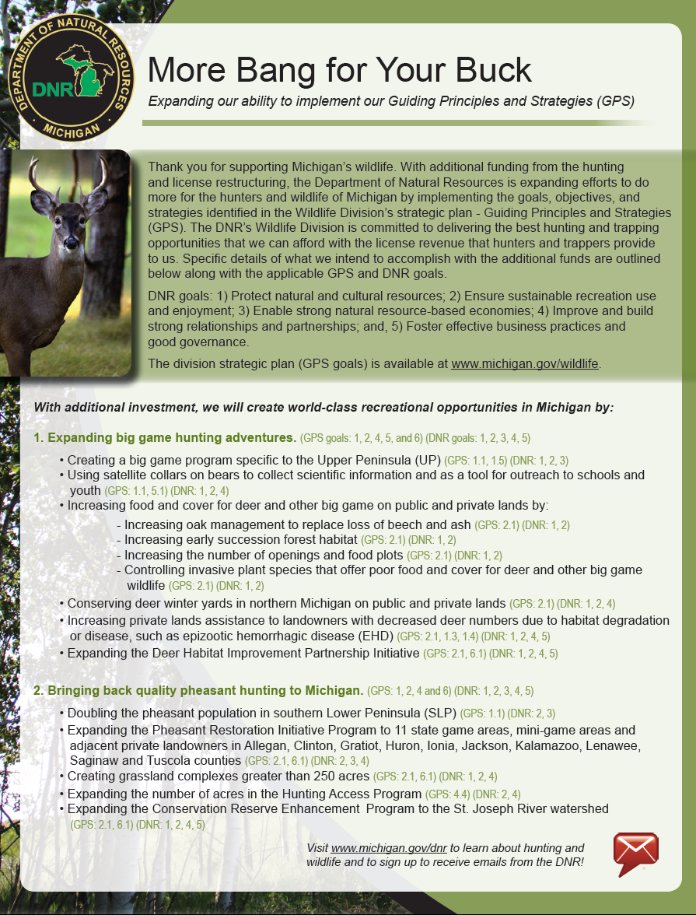
Appendix A: More Bang for Your Buck Brochure

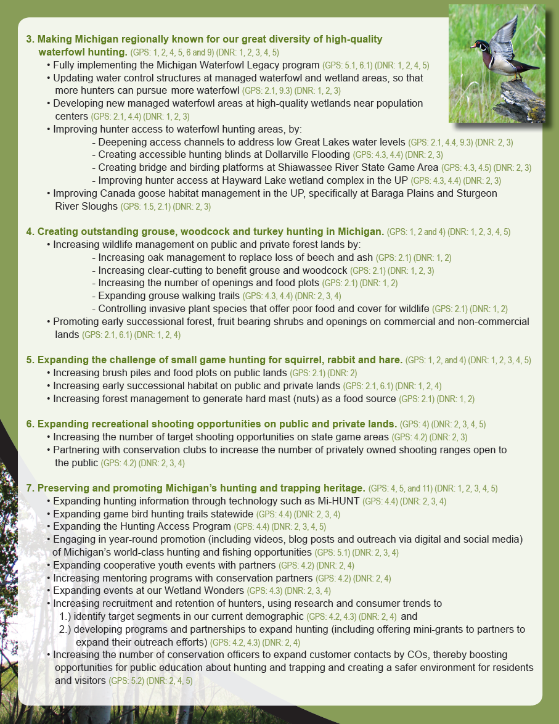

Appendix B: Wildlife Division Regions
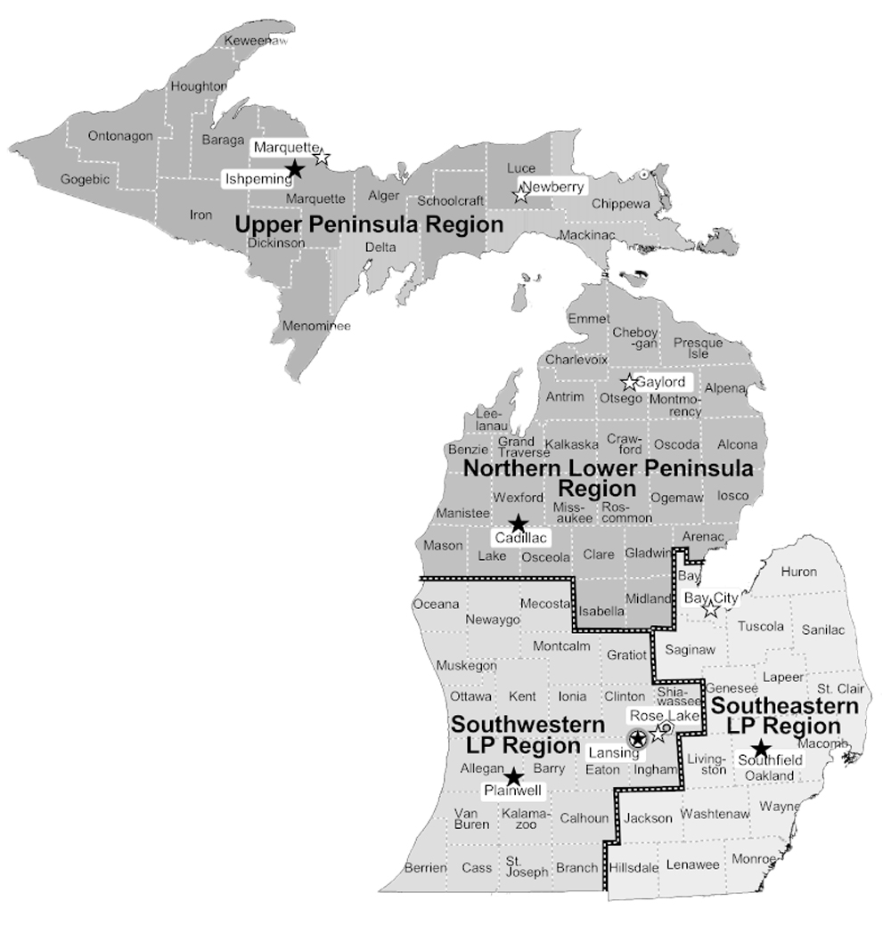
Note: When contacting your Project Regional Manager, please put “2015-2 WHGP” in the email subject line.
Terry Minzey, Regional Manager  Upper Peninsula Region  Ishpeming Field Office  1985 US 41 Hwy West  Ishpeming, MI 49849  E-mail: MinzeyT@michigan.gov | Tim Payne, Regional Manager  Southeast Lower Peninsula Region  Southfield Operations Service Center  26000 W. Eight Mile Rd  Southfield, MI 48034  E-mail: PayneT@michigan.gov | Clay Buchanan, WHGP Coordinator  PO Box 30444  Lansing, MI 48909  Telephone: (517) 284-6214  E-mail: BuchananC1@michigan.gov
Rex Ainslie, Regional Manager  Northern Lower Peninsula Region  Cadillac Operations Service Center  8015 Mackinaw Trl.  Cadillac, MI 49601  E-mail: AinslieR@michigan.gov | Steve Chadwick, Regional Manager  Southwest Lower Peninsula Region  Plainwell Operations Service Center  621 North 10th St.  Plainwell, MI 48080  E-mail: ChadwickS@michigan.gov

Appendix C: Notification of Contractor/Vendor Selection and Bid Tabulation Approval
Michigan Department of Natural Resources - Grants Management
Notification of Contractor/Vendor Selection and Bid Tabulation Approval
This information is required by Authority of Act 299, P.A. 1980 as amended, for reimbursement of project costs.
GRANTEE: |  |  | PROJECT NO: |  |  |  |  | PROJECT NAME:
COMPLETE SECTIONS A. AND B. BELOW, AS APPLICABLE TO YOUR PROJECT
SECTION A
I propose to award contracts to the following contractors, after DNR concurrence with this proposed selection and in accordance with the procedures specified in the Development Project Procedures booklet (IC1912).
Attached is a copy of the bid or quote tabulation.
Contractor/Vendor |  |  |  | Contract Amount |  | Project Scope Item |  |  |  | Proposed Award Date
1. |  |  |  | $
2. |  |  |  | $
3. |  |  |  | $
4. |  |  |  | $
SECTION B
Please check all that apply:
Fewer than three bids or quotes were received; attached to this Notification is written justification for the recommended award of the contract to the lowest bidder, including a description of the efforts taken to advertise for bids or solicit quotes.
I propose to award the bid to the second lowest bidder, upon concurrence by the DNR; attached to this Notification is written justification for rejecting the lowest bid.
CERTIFICATION
I hereby certify that the contractor(s)/vendor(s) listed in A. above was chosen for selection according to the procedures outlined in the Development Project Procedures booklet and the Project Agreement. In accordance with those procedures, I have reviewed the qualifications of the recommended bidder, have accurately calculated the total bid price, and assert that the bidding was conducted as put forth in the specifications and bid documents approved earlier. Further documentation of the contractor selection process will be provided upon request.

 | Grantee’s Signature (REQUIRED) |  |  |  |  |  | Date
Return this completed notification along with all required attachments to:
Grants Management  Michigan Department of Natural Resources  PO Box 30425  Lansing MI 48909-7925 |  |  |  |  |  |  |  |  | Upon concurrence by DNR,  a copy of this approved notification will be returned to the Grantee
FOR DNR USE ONLY
The Michigan Department of Natural Resources concurs with your recommendation to award the contract to the bidder(s) as specified in A. above.
 | DNR Grant Coordinator |  |  |  |  |  | Date
PR1911-1 (Rev. 03/19/2015)

Appendix D: Example of Private Landowner Authorization Letter

March 18, 2015

Conservation Resource Alliance
5678 Your Rd.
My Town, MI

RE: Permission for Aquatic Habitat Grant work

Dear Mr. Green,

I Fred Bear, as landowner of the property located at 12345 My Way Dr., Your Town, MI, authorize Conservation Resource Alliance to perform Wildlife Habitat improvement work on my property as outlined in their Wildlife Habitat Grant Agreement with the Michigan Department of Natural Resources. A copy of the deed/most recent tax statement showing the parcel number, legal description and ownership is attached.

Thank y7ou.

Fred Bear, Landowner

Appendix E: Example of Public Landowner Authorization Letter

March 18, 2014

Huron Pines
5678 Your Rd.
My Town, MI

RE: Permission for Aquatic Habitat Grant work

Dear Mr. Green,

I Joe Black, as an authorized representative for Gratiot County, confirm that the project property is owned by the County and as such, authorize Huron Pines to perform Wildlife Habitat improvement work on the property as outlined in their Wildlife Habitat Grant Agreement with the Department of Natural Resources.

Thank you.

Joe Black, Gratiot County Supervisor

Michigan Department of Natural Resources - Grants Management
Volunteer Labor Sign-In and Time Record
This information is required by authority of Part 5 of Act 451, P.A. of 1994, as amended, to receive payment.
Grantee: Volunteer hours must be documented. Grantee should provide this sign-in sheet at the project work site for volunteers to certify their time. Please use additional sheets as necessary. Grantee’s Representative shall sign and submit this sign-in sheet with reimbursement request.
(please print)
 | Project Name (as listed on Project Agreement) |  |  |  |  |  | Project Number (per Project Agreement)  –
 | Grantee |  |  |  |  |  | Name and Title of Grantee Representative
Volunteer(s): Please print all information and initial each entry to certify the information listed is correct.
Name |  |  |  | Activity Description |  |  |  | Date | Hours |  | Initials of Volunteer
Grantee Representative Certification
 |  | I certify that the above information including all attachments is complete and accurate to the best of my knowledge.
 |  | Grantee Representative Signature |  |  |  | Date
Submit this completed record with Reimbursement Request.

Appendix F: Volunteer Labor Sign-In and Time Record

